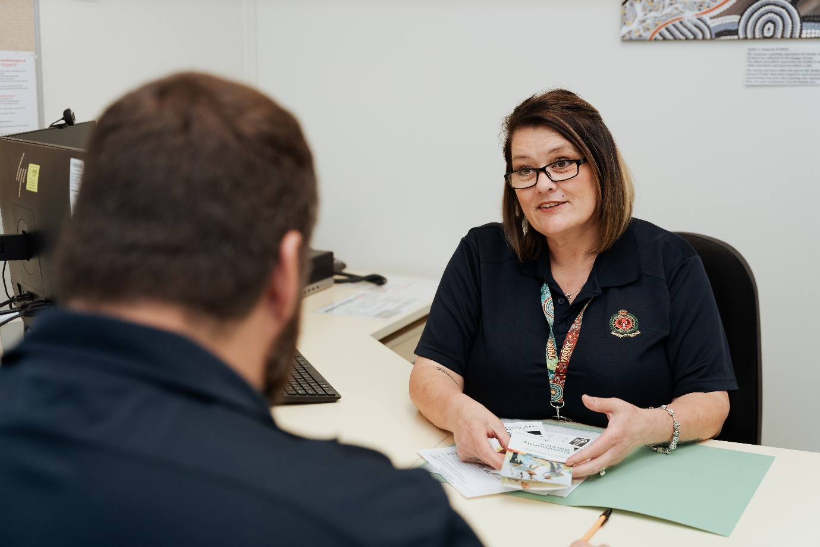

Community Corrections Officer
Information Pack



About the Department for Correctional Services

The Department employs approximately 2000 staff and has responsibilities for nine prisons and 15 Community Corrections Centres across the state. Our vision is making a difference to reduce reoffending.
We work towards this through the contribution of Community Corrections Officers who are employed to supervise and provide targeted case management to persons in the community subject to community-based supervision orders.
We strongly promote diversity and equity in our workforce, which directly contributes to greater effectiveness and better outcomes. The Department receives strong bipartisan support on the strategic direction of the agency and is committed to achieving our set targets.
In a supportive and collaborative environment, you will encounter professional challenges and work alongside dedicated and passionate people who work to support behaviour change and reduce reoffending whilst focussing on community safety.
Community Correctional Centres are located across South Australia with centres located in the following metropolitan and regional areas.
- Adelaide
- Port Adelaide
- Edwardstown
- Noarlunga
- Holden Hill
- Elizabeth
- Murray Bridge
- Mount Gamber
- Berri
- Port Pirie
- Port Augusta
- Whyalla
- Port Lincoln
- Ceduna
- Coober Pedy

About the Role
The role of Community Corrections Officer provides an exciting opportunity to make a difference to the South Australian community to work in our Community Corrections setting where you can support people to address and change their behaviours and comply with the requirements of their community-based orders.
The Department is seeking individuals to join our diverse team in supporting and delivering our strategic agenda and direction.

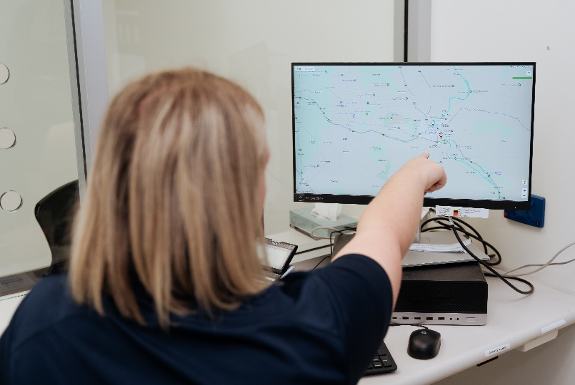

Community Corrections Officer Level 3 (CCO3) is responsible for the case management of low to moderate risk adult offenders placed on community based orders issued by the Courts and Parole Board.
Community Corrections Officer, Level 3 is responsible for the:
- Monitoring and compliance of offenders in accordance with their community-based orders and conditions.
- Provision of non-compliance and progress reports to the Courts and Parole Board.
- Assessing clients’ needs and referring offenders to suitable treatment and services to address their needs and reduce reoffending.
- Ensure completion of targeted and individualised case management plans to ensure appropriate and effective service delivery.
- Accurate and comprehensive record keeping.
- Completion of reports for the Courts and Parole Board.
Required Qualification:
Nil.

Community Corrections Officer Level 4 (CCO4) is responsible for the case management of moderate to high-risk adult offenders placed on community based orders issued by the Courts and Parole Board.
Community Corrections Officer, Level 4 is responsible for the:
- Monitoring and compliance of offenders in accordance with their community-based orders and conditions.
- Provision of non-compliance and progress reports to the Courts and Parole Board.
- Contribute to and assist in appropriate and comprehensive release planning and case conferencing of high-risk offenders
- Assessing clients’ needs and referring offenders to suitable treatment and services to address their needs and reduce reoffending.
- Implementing intervention and case management strategies to meet immediate and long-term intervention and treatment gaols.
- Ensure completion of targeted and individualised case management plans to ensure appropriate and effective service delivery.
- Accurate and comprehensive record keeping.
- Completion of comprehensive reports for the Courts and Parole Board.
Required Qualification:
PO: Appropriate tertiary degree level qualification in community services, sociology, criminology, justice, correctional practice, social sciences, human services, health or related field.
AHP: Appropriate degree or equivalent qualification which gives eligibility for full membership of the Australian Association of Social Workers.
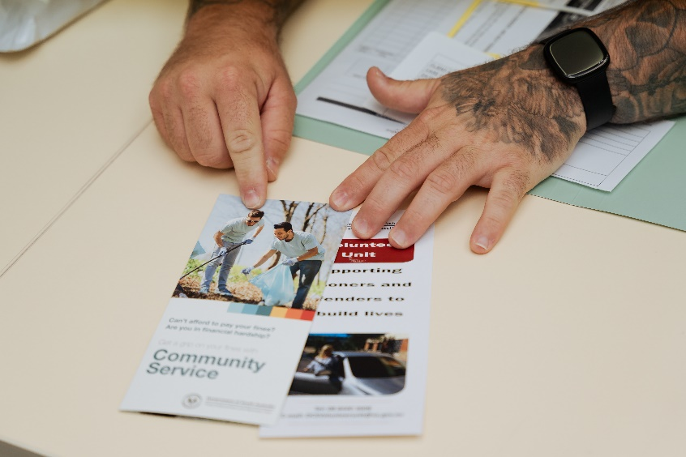
About the Employment Pool
Should you be successful, you will be advised (in writing) that you have been recommended onto this Employment Pool. The Employment Pool will remain active for 12 months and during this time you may be contacted for an offer of employment. You are not required to accept any or all offers made to you, and DCS is not obliged to offer you any opportunities.
Please note: DCS reserves the right to advertise similar positions outside of this pool process.
Remuneration
We offer a competitive salary and great opportunities for professional development and career advancement. Please refer to the advertisement of the position for the specific renumeration details.

Special Conditions
- Incumbents will be required to satisfactorily complete a National Criminal History check.
- A current South Australian Driver’s Licence is essential, with a capacity and willingness to drive, including in country locations.
- A flexible approach to working hours is required.
- Some work may be required outside of core business hours.

To find out more about these roles, including the key accountabilities and special conditions, please refer to the individual job and person specifications. You may also be required to undertake some further pre-employment screening activities if you accept an offer from the pool.

Flexibility Statement
The South Australian public sector promotes diversity and flexible ways of working including part-time. Applicants are encouraged to discuss the flexible working arrangements for this role.

Enquiries & Application
Email: dcsccapplications@sa.gov.au

Application Instructions
Your written application should include:
- A cover letter of no more than 2 pages that addresses the 4 criteria outlined in the advert, quoting the vacancy number and outlining your skills, knowledge and experience relevant to the role you are applying for
- A CV or resume outlining your qualifications and employment history
- A clear indication of which Community Corrections Offices location/s (outlined above) that you are willing to be considered for.
- A copy of your qualification (if you are applying for a CCO4 role).
- Applicants must include the name, address and contact number of three current referees who can provide recent information regarding your relevant work/experience – if possible, provide your referees with a copy of the job and person specification. Please be aware that the panel is free to obtain work reports from a current supervisor/manager (if not nominated), if appropriate
- If you are not currently employed in the Department for Correctional Services, you will also need to complete all sections and sign the Employment Declaration form.

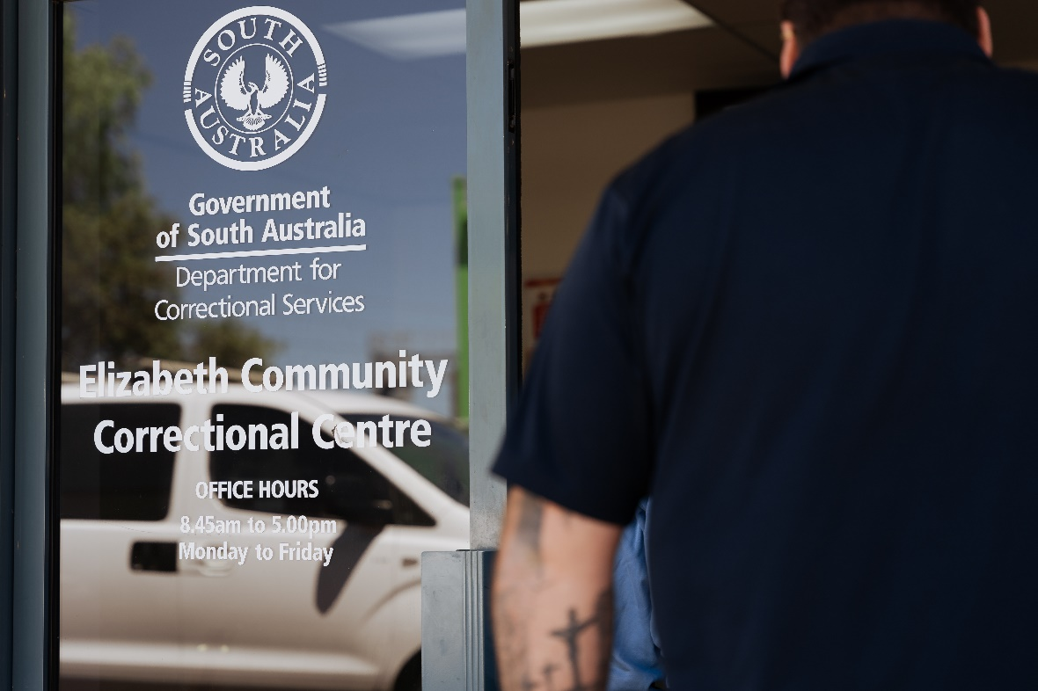

Employment Conditions
A requirement to understand, observe, conform and adhere to:
- Legislative requirements that apply to the role. This includes, but is not limited to, the Public Sector Act; Correctional Services Act, Work Health & Safety Act, Return to Work Act, Equal Opportunity Act, Independent Commissioner Against Corruption Act, the State Records Act, and various relevant industrial awards and enterprise agreements. The Public Sector Principles and Practices including the SA Public Sector Code of Ethics, the Professional Conduct Standards, the Commissioner’s Determinations and Guidelines, Information Privacy Principles, Information Sharing Guidelines, DCS Human Resource policies and guidelines and DCS Core Values.
- DCS employees will maintain the integrity and security of official or confidential information for which they are responsible. Employees will also ensure that the privacy of individuals is maintained and will only release or disclose information in accordance with relevant legislation, industrial instruments, policy, or lawful and reasonable direction.
- Work health and safety and injury management requirements as set out in relevant legislation, Public Sector and DCS policies and procedures, including complying with any reasonable instruction associated with these documents.

Strategic Documents

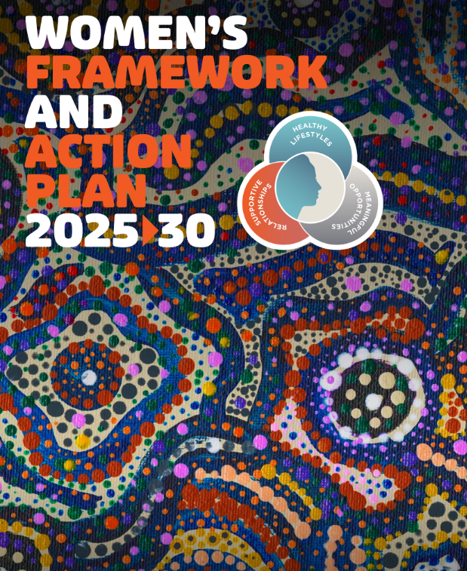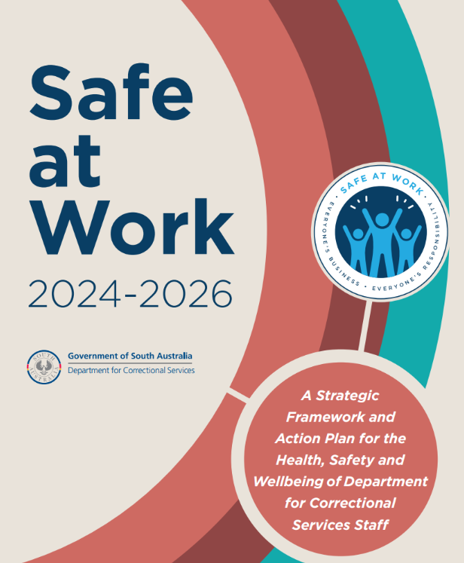

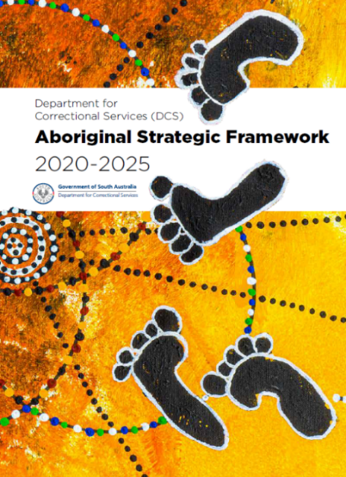
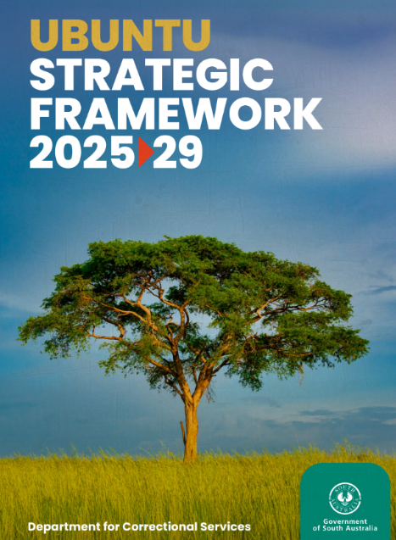



C O R R E C T I O N S . S A . G O V . A U

D E P A R T M E N T F O R C O R R E C T I O N A L S E R V I C E S
400 400 King William Street Adelaide South Australia 5000
GPO Box 1747 Adelaide SA 5001
08 8226 9000

